A picture containing clipart

Description generated with very high confidence

Azure 103 Module 3

Hands On - 1

Azure Certification Training

[**support@intellipaat.com**](mailto:support@intellipaat.com)

**+91-7022374614**

**US: 1-800-216-8930(Toll Free)**

**Azure 103, Module 3, Hands On - 1**

**Create a basic Linux VM in Azure**

**Problem Statement: Create a basic Linux Virtual Machine in Azure.**

**Solution:**

**Creating a Linux Virtual Machine:**

**Step 1:** Go to portal.azure.com and sign into your Azure account. Azure dashboard page of your Azure portal will appear on the screen as shown below.

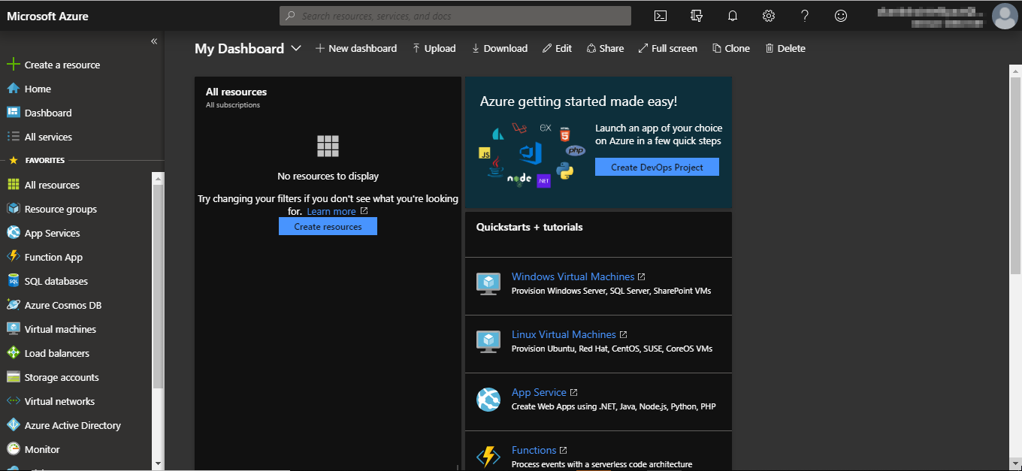

**Step 2:** Navigate to the **Resource groups** option on the left side menu as shown in the following image.

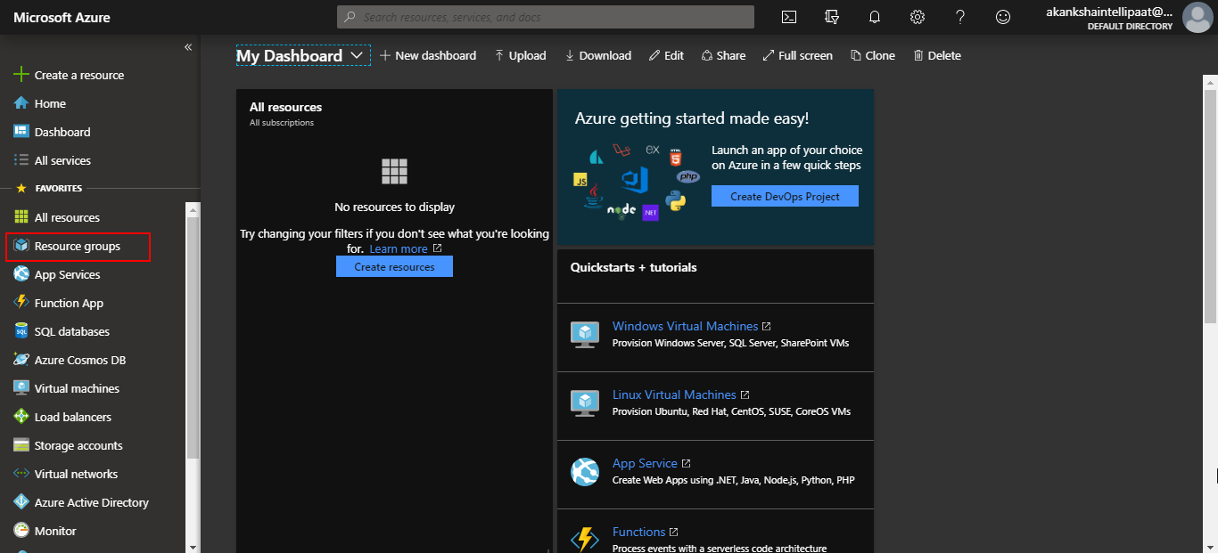

**Step 3:** Click on **Resource groups** option and you will be taken to the resource groups dashboard where you’ll see various options such as **add, edit column and more.** Click on add option.

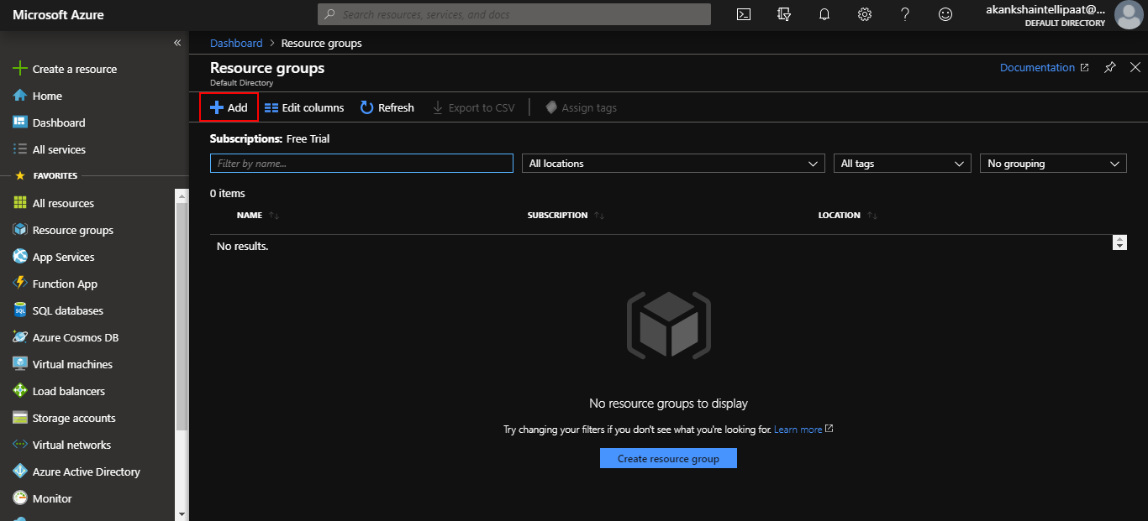

**Step 4:** Provide a name for your resource group in the respective field. You can keep the subscription as per your Azure subscription. And then click on Review & create.

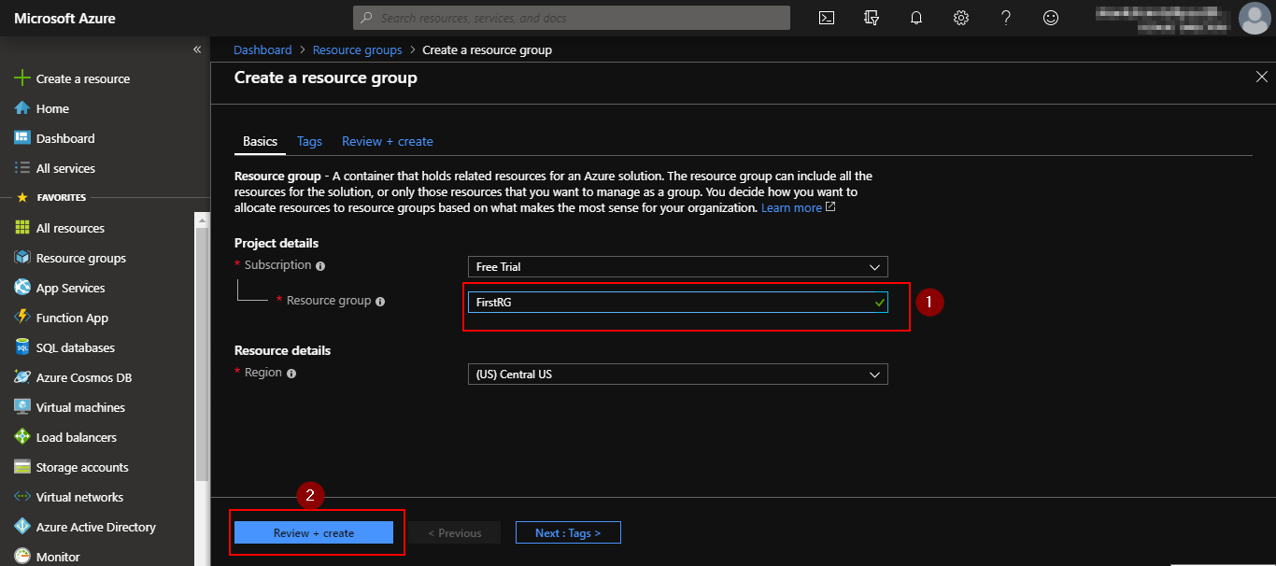

**Step 4:** You will be taken to the final page in creating a resource group. Check if the **“validation passed”** message is displayed as shown in the following screenshot, then click on **create.**

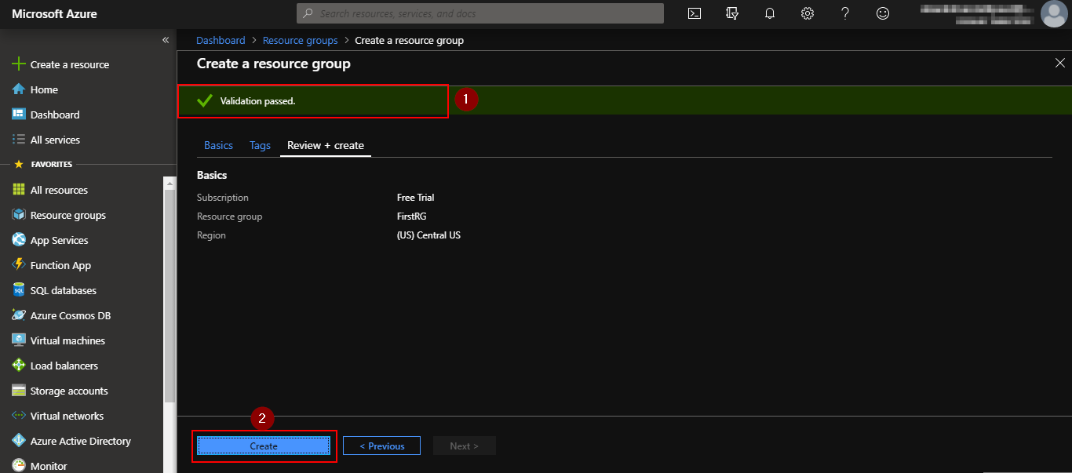

**Step 5:** You’ll get a notification saying that the resource group is created and you will be able to see your resource group listed in your resource group dashboard.

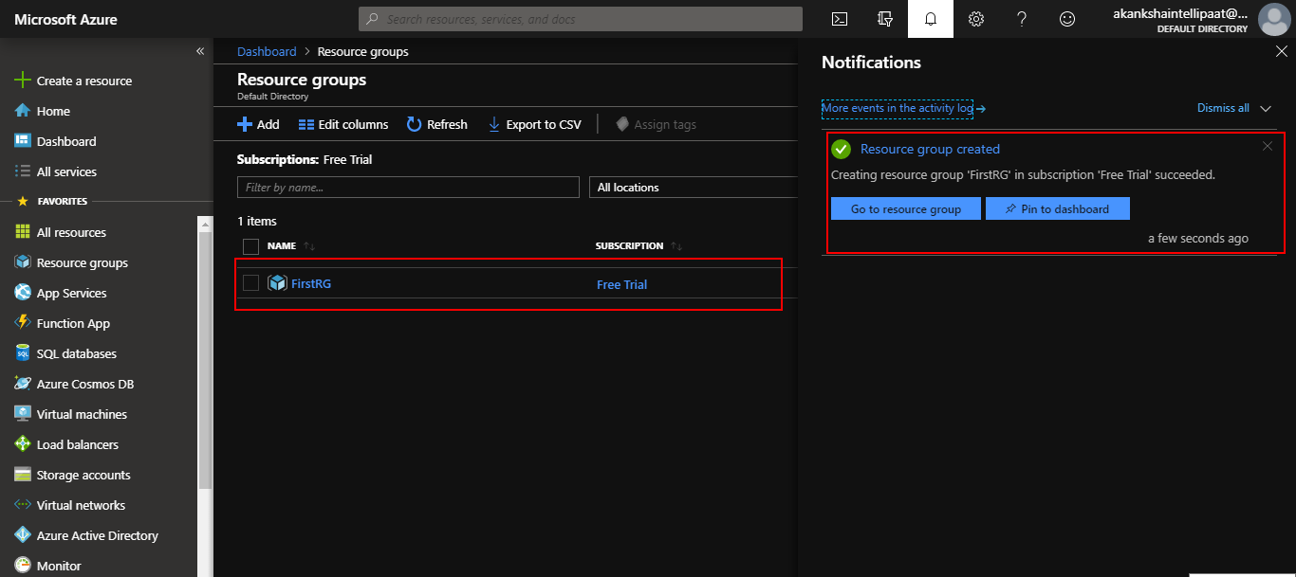

**Step 6:** Go back to the dashboard and select **Virtual Machine** from the left pane menu in Azure portal.

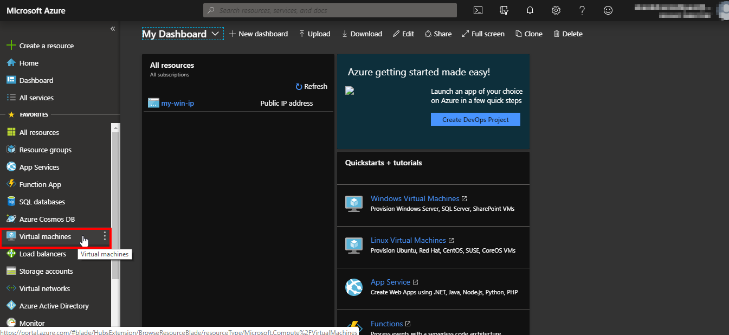

**Step 7:** When the following page appears, click on add option.

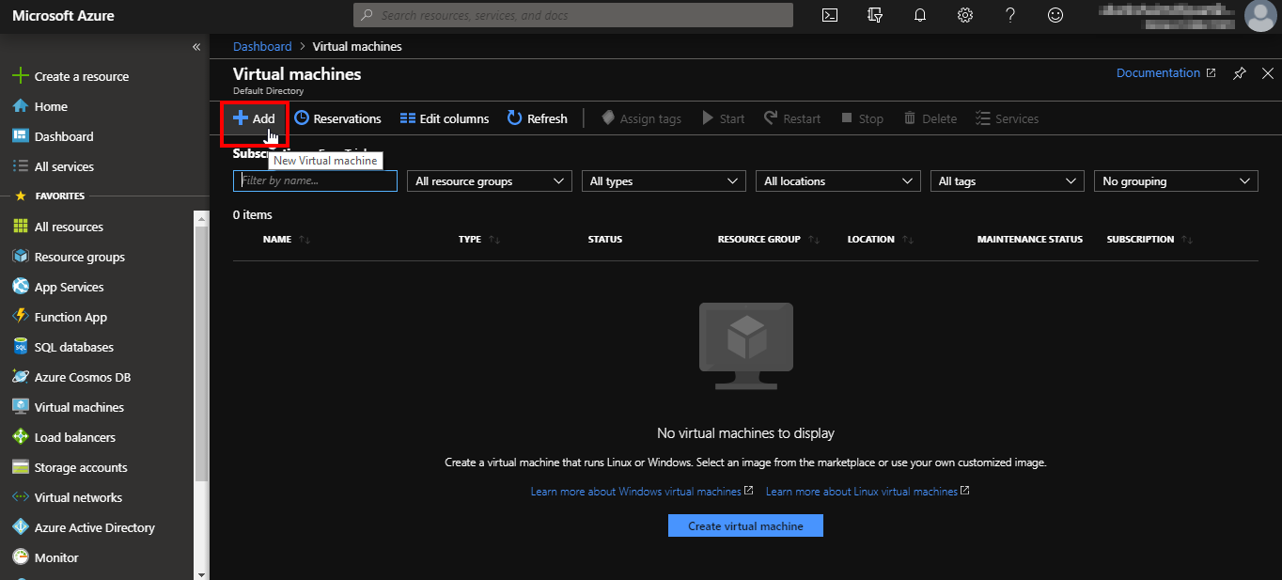

**Step 8:** Select the resource group that we just created in the resource group field and then provide the name of the VM. You can keep the subscription as per your Azure subscription. In the image field, select the OS you want for your VM, then choose the size as ‘Standard DS1 v2’.

You can keep the region and availability options fields with default values as shown below.

**Note: The name for the resource should be unique.**

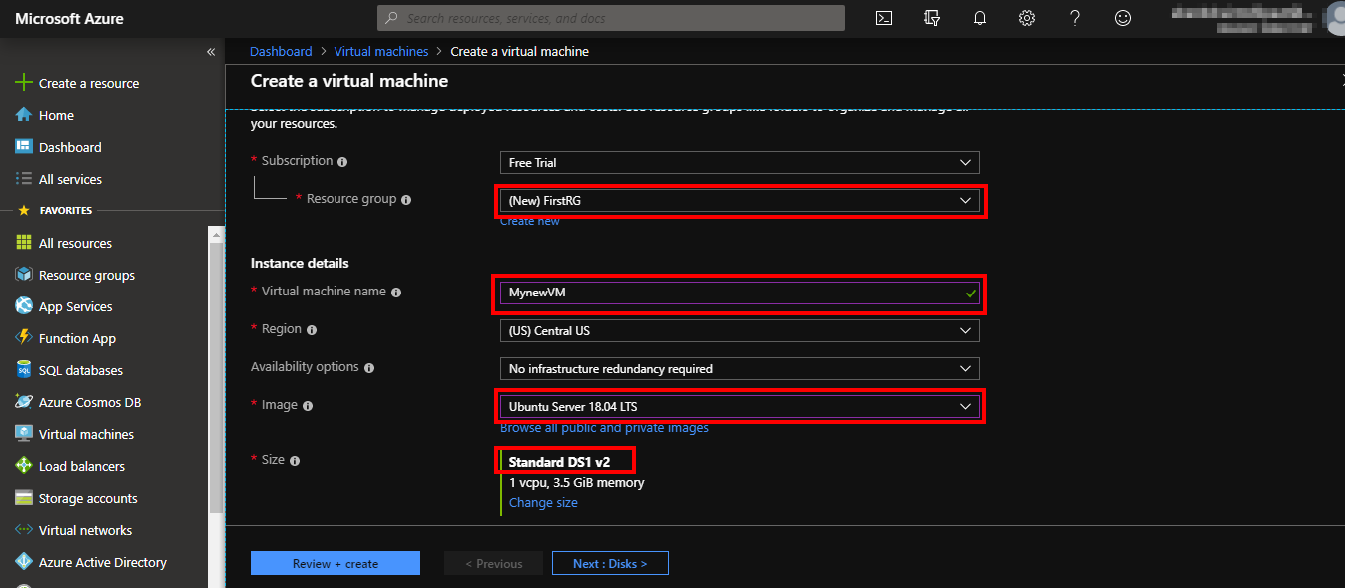

**Step 9:** Staying at the same page, scroll down. You’ll see some more fields to be filled in. Choose SSH public key in authentication type field, since we will be SSHing into the VM to connect with it. Provide any username that you want for your VM.

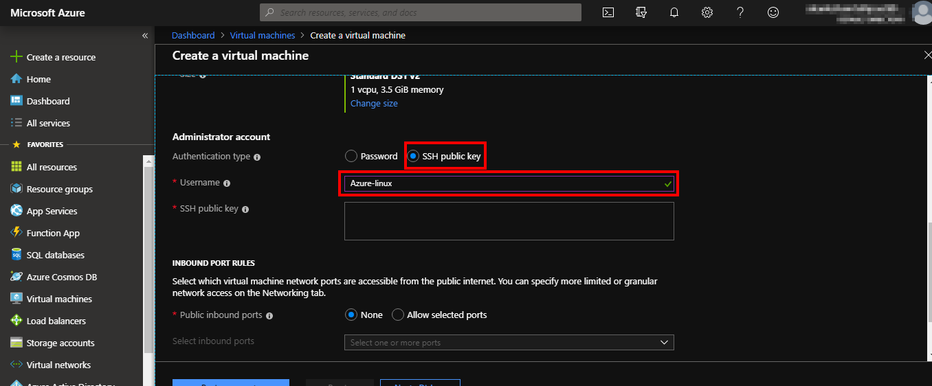

**Step 9:** Download and installputty from [**this**](https://www.putty.org/) webpage. Once downloaded and installed, open putty keygen or key generator, it will look like the following screenshot.

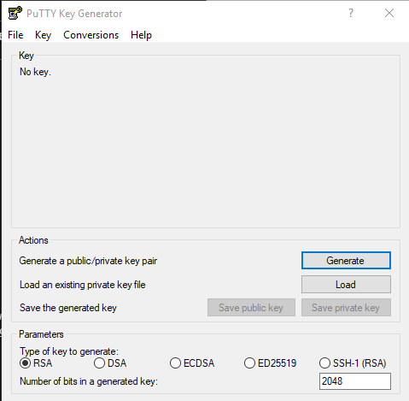

Click on generate button and public key will be created for you as shown below

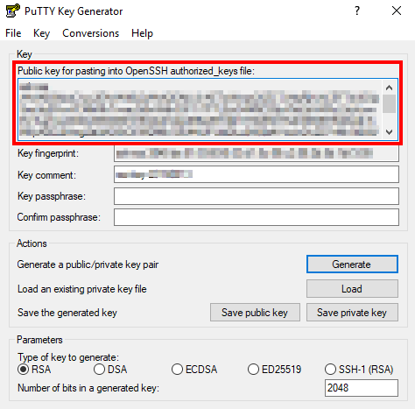

**Step 10:** Copy the public key and paste it in the public key field in Azure portal as shown below.

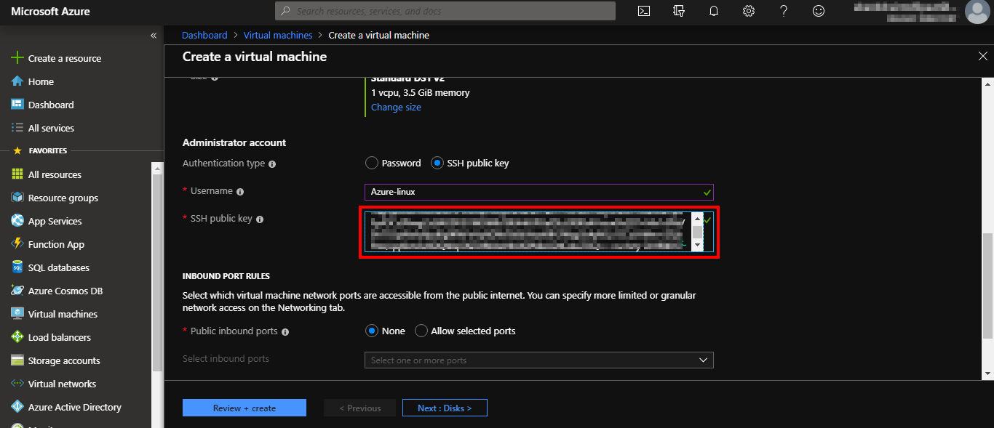

**Step 11:** In public inbound ports, select “allow selected ports” and then from the dropdown, select SSH. If you want to run a web server to create any application on your VM then you also need to HTTP. 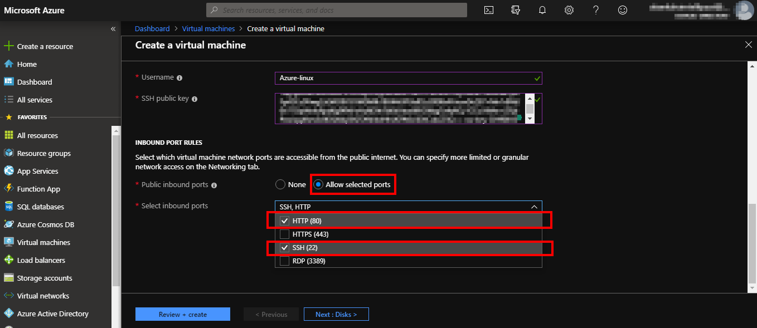

**Step 12:** Now click on review + create, then in next page, click on create. 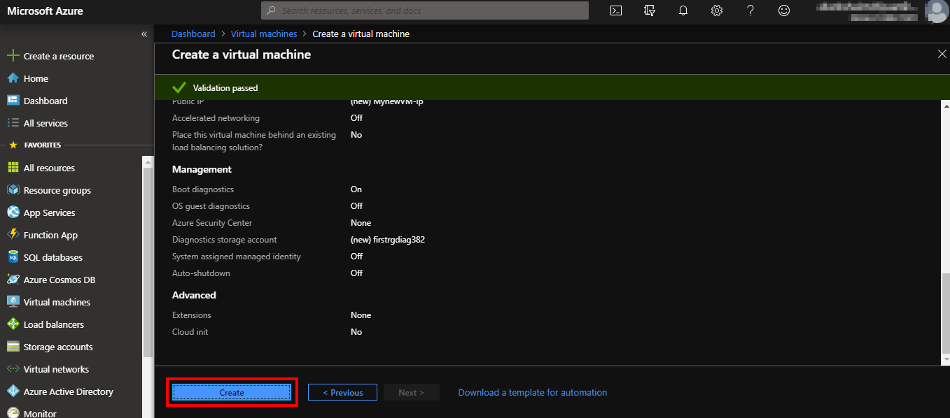

**Step 13:** Go back to putty keygen tool and click on save private key.

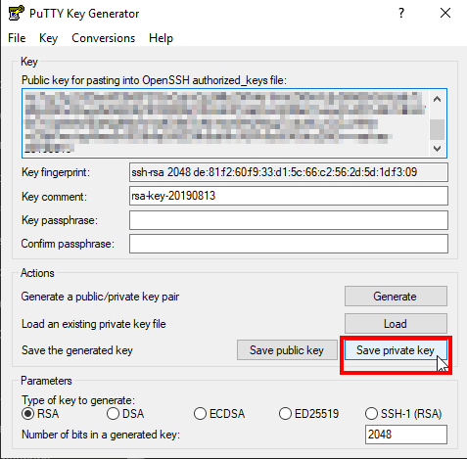

**Step 14:** Go back to putty keygen tool and click on save private key and then save the ppk file.

**Step 15:** Once the deployment is complete, you’ll get a message saying the deployment is complete.

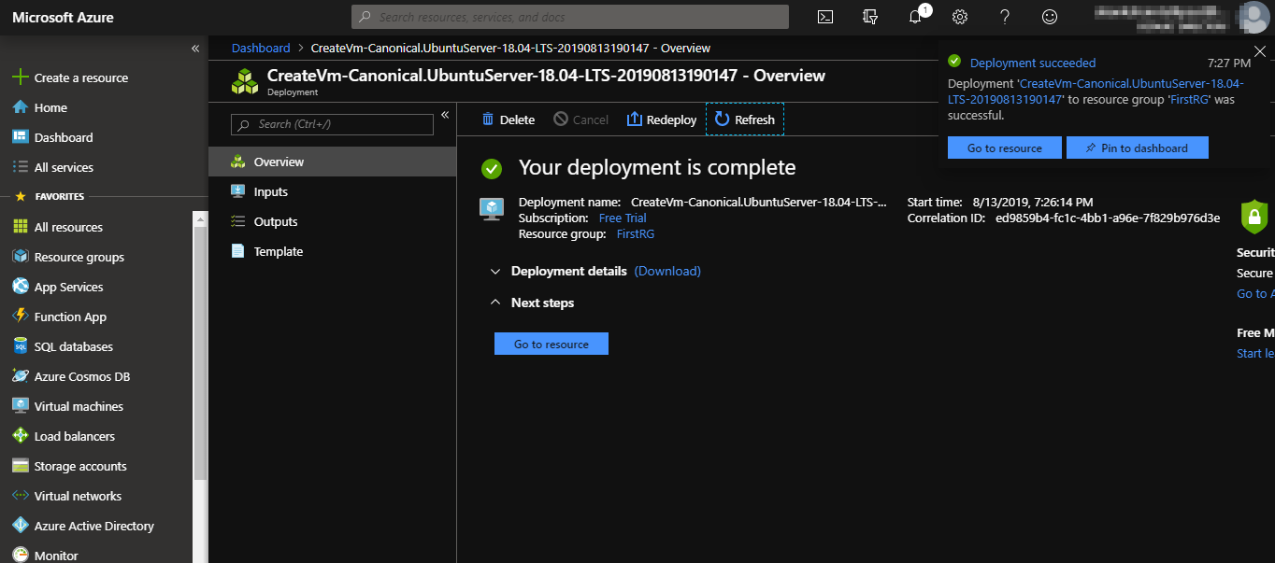

**Step 16:** Open putty tool. It should look like the following screenshot.

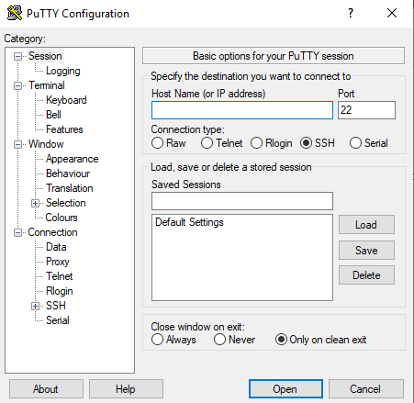

**Step 17:** Copy the public IP address of your VM.

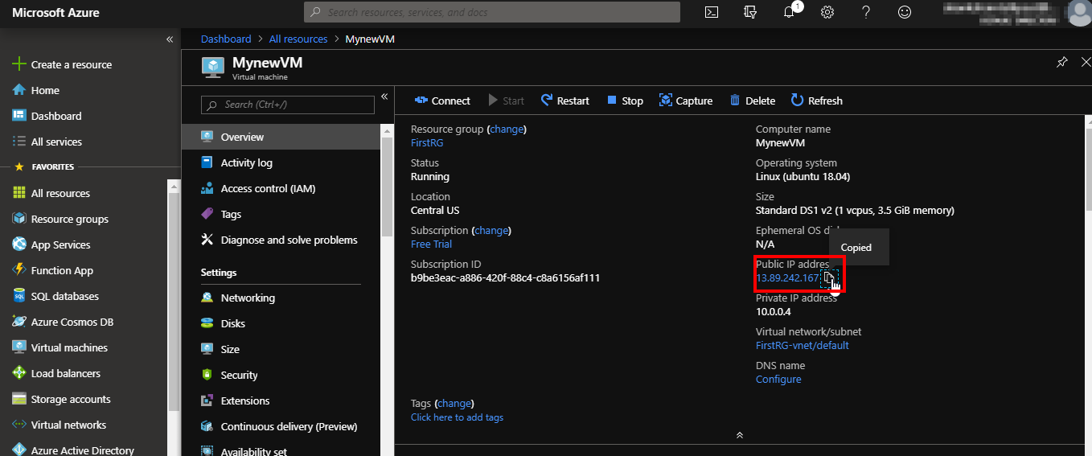

**Step 17:** Paste the IP address in the Host name field in Putty tool and then click on SSH option from the right menu bar.

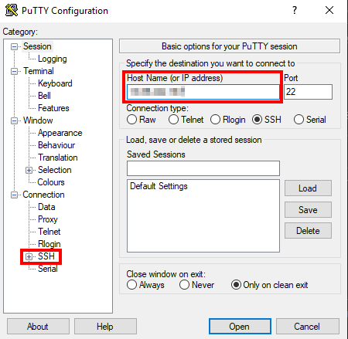

**Step 18:** In sub menu of SSH, select Auth. Then browse and select the private key you saved in step 14, and then click on open.

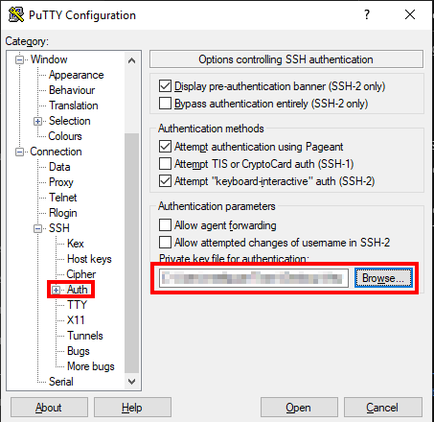

**Step 19:** In putty security alter pop up box, click on yes and then provide the username that you set in step 9.

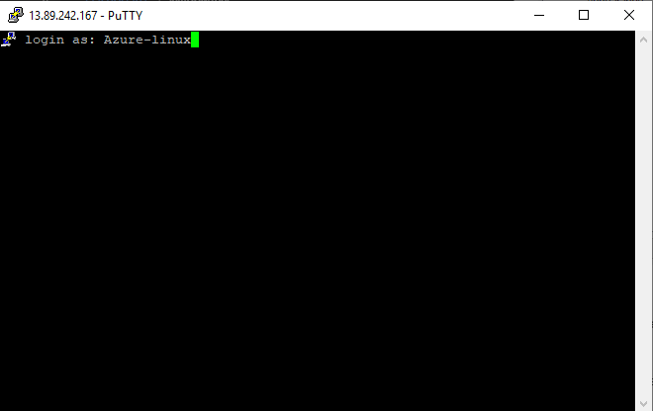

**Step 20:** After connection is successful, it should look like the following screenshot:

